**Build a Website in a Weekend.**

Resources:

These are programs that you will use during the weekend. You will be able to take copies of these programs home at the end of the weekend. They are all programs that can be shared freely:

* Notepad
* Kompozer
* Menumaker
* Audacity
* Chrome Portable

Hardware:

* Cameras
* Headphones

Other:

* Image Library

Prepared webpages. As well as making your own web pages from scratch, these are pages that you will be changing during the weekend:

* RedderThanRed.html
* ColorChanger.html
* Snow.html
* ThisIsMe.html
* ImageMap.html
* Quiz.html
* 8ball (java game)
* Changing pictures example java code (a way of showing different pictures)
* Colourchooser (how to colour text or text background in a page)
* Quiz1 (quiz game)
* Snow2
* Valentine
* Zoetrope (cool way of showing pictures)

Websites: These are websites you might use once you get home for help and inspiration:

HTML Basics

<http://www.w3schools.com/html/default.asp>

HTML Cheatsheets:

<http://www.simplehtmlguide.com/cheatsheet.php>

<http://www.webmonkey.com/2010/02/html_cheatsheet/>

<http://skillcrush.com/wp-content/uploads/2012/06/HTML-Cheatsheet-Skillcrush.pdf>

CSS basics:

<http://www.w3schools.com/css/default.asp>

<http://www.webmonkey.com/2010/02/css-guide/>

<http://www.webmonkey.com/2010/02/how-css-works/>

<http://www.webmonkey.com/2010/02/linking-stylesheets/>

CSS Cheatsheet:

<http://www.w3schools.com/cssref/default.asp>

<http://www.javascriptkit.com/dhtmltutors/cssreference.shtml> (*)

<http://libertyboy.free.fr/computing/reference/css/index.php>

<http://www.cheatography.com/davechild/cheat-sheets/css2/>

Colour codes:

<http://www.visibone.com/colorlab/>

<http://www.mathsisfun.com/numbers/hexadecimal-color-names.html>

<http://www.colourlovers.com/web/blog/2008/04/22/all-120-crayon-names-color-codes-and-fun-facts>

Resources for html code:

<http://codepen.io/postpop/pen/sJzbm>

<http://codepen.io/rlemon/pen/vAlyg>

Free Portable Software

<http://portableapps.com/apps>

Coding in General

<http://www.codecademy.com/>

**Friday eve**

**Webpage 1 – Hello.html**

Learning Aspects:

* Creating a new html file, naming conventions, opening html files in browser and notepad, editing html, saving html files.
* The basic needs for a HTML file.
* Parts of a HTML file: Title, head, body, tags, css
* Using folders to organise your files

1. Open notebook.

Save as: **helloworld.html**

File type: **all files**

|  |
| --- |
| Now type in:  **<html>**  **<head>**  **</head>**  **<body>**  After you have saved it for the first time using Save as, always just SAVE – otherwise it will forget to be a web page!  **Hello World**  **</body>**  **</html>** |

1. Now Save and open as a web page.
2. Now add some style:

* Refer to cheat sheet. <http://www.javascriptkit.com/dhtmltutors/cssreference.shtml>
* Play with body tags:
* Formatting:
* (Hyperlinks – same page opens, new tab open…)
* CSS *inline* / *internal stylesheet* / *external stylesheet*

|  |
| --- |
| <html>  <head>  **<STYLE type=text/css>  BODY {**  Notice the wiggly brackets, the colon and semi colon are really important!  **background-color: yellow; } </STYLE>**  </head>  <body>  Hello World  </body>  </html> |

1. In head section (internal) (like above)

Play with the styles

|  |
| --- |
| **<STYLE type=text/css>** BODY {  Some possible choices.  Go to w3schools css reference for more ideas.  color: #green; /*text color*/  font-size:8pt;  font-family:arial, san-serif;  background-color:yellow; } **</STYLE>** |

Play with colours. For colours, instead of choosing colour names, use 6 numbers or letters up to ‘F’

|  |
| --- |
| Background-color: #ffcc33; |

**Saturday Morning**

**Webpage2 – RedderThanRed.html**

Learning Aspects:

* Understanding number bases: Decimal, binary, hexadecimal.
* The physics of colour using light, and the link to hexadecimal.
* Becoming more familiar with web pages: Title, images, tags

Part 1 – understanding Hexadecimal > Webcolors

Part 2 - Finding your way around a bigger webpage, images, hexadecimal, colours

RedderThanRed template given with image library

* Choose a core colour
* Change title
* ‘colour words’
* Hexadecimal (Hexadecimal number squares (*))
* Colours in hexadecimal
* Images

**Webpage3 –Quiz.html**

Learning Aspects:

* Exploring longer web pages
* Reading java

Or

**Imagemap.html**

Leaning Aspects:

* Adding hyperlinks to different parts of an image.

**Saturday afternoon**

**Webpage 4 – ColorSampler**

Learning Aspects:

* CSS reviewed

**Snippits**

Learning Aspects:

* How to use tables to structure information
* How to use a WYSIWYG program to help you write code
* Using small pieces of code inside a web page

**Tables**

|  |
| --- |
| <table>  *<thead>*  *<tr>*  *<th></th>*  *<th></th>*  *<th></th>*  *<th></th>*  *</tr>*  *</thead>*  <tbody>  <tr>  <td></td>  <td></td>  You can use copy and paste to make this easier to do, or use Kompozer.  <td></td>  <td></td>  </tr>  <tr>  <td></td>  <td></td>  <td></td>  <td></td>  </tr>  <tr>  <td></td>  <td></td>  <td></td>  <td></td>  </tr>  </tbody>  </table> |

|  |  |
| --- | --- |
|  | Learning Aspects: |
| **ColorChooser** | Choose the colour of text and background of a sample of text |
| **Magic8Ball** | A fun game – let the 8 Ball decide |
| **Snow** | Snow falls down the page |
| **Changing pictures** | A piece of code to make a picture slide show |
| **Quiz** | Ask questions in random order, check answers |

**Saturday Evening**

**Online coding sites**

* <http://turtleacademy.com/>
* <http://code.org/learn>
* <http://www.crunchzilla.com/code-monster>
* <http://www.codecademy.com/goals/hour-of-code>
* <https://thimble.webmaker.org/>

**Sunday Morning**

**Building a home page from scratch**

Learning Aspects:

* Reviewing making a new web page.
* Developing a theme
* Planning and design
* Linking a home page to other pages
* Creating a new html file, naming conventions, opening html files in browser and notepad, editing html, saving html files.
* The basic needs for a HTML file.
* Preparing to present to parents.

Presentation:

* What a web page is
* What you need to see a web page
* What you need to change a web page
* (SA – How to host a web page)
* Best thing about making your own web page x 3
* Most Complicated thing I have learnt x2

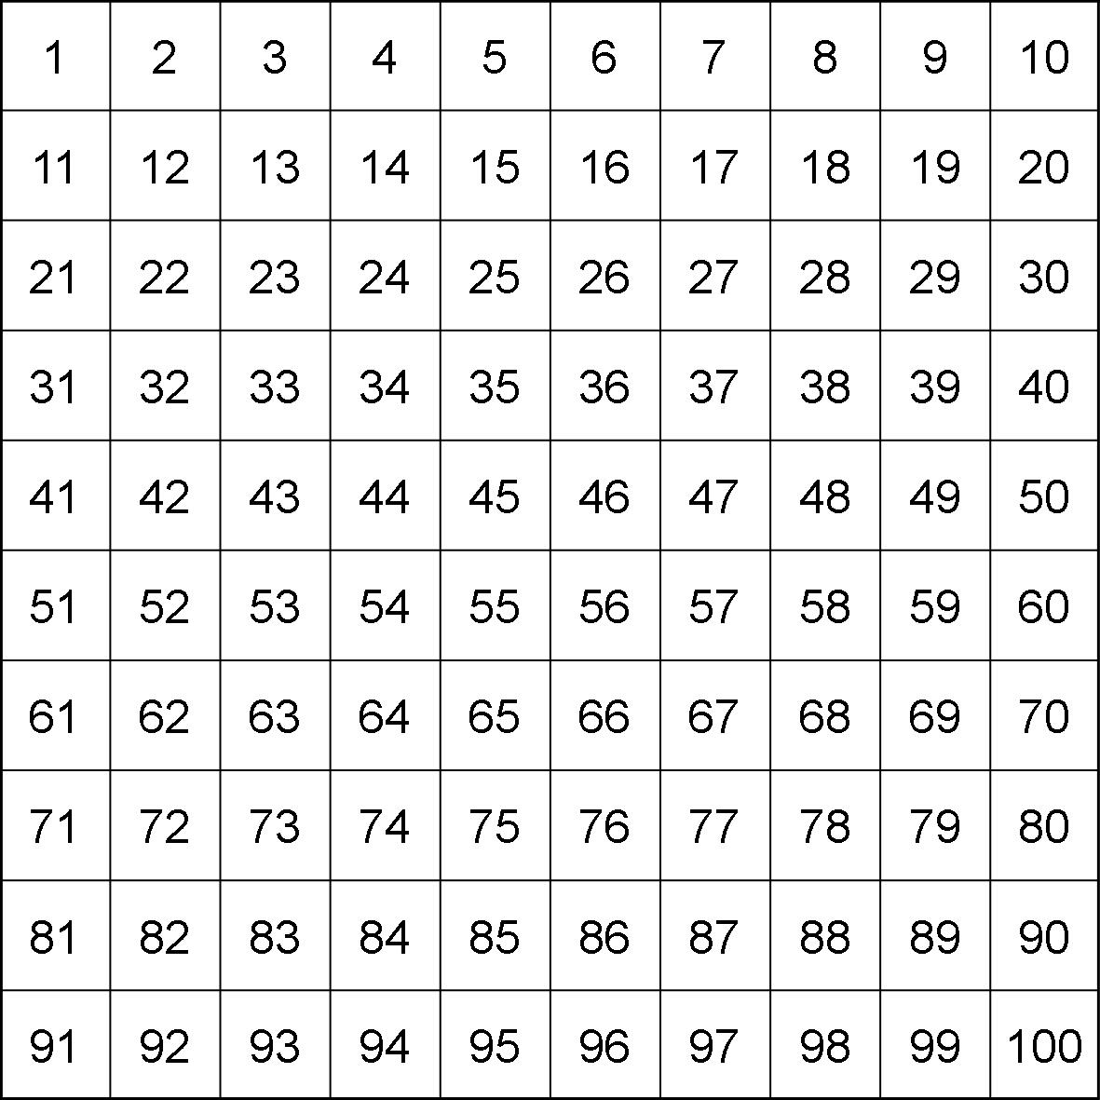

|  |  |  |  |  |  |  |  |  |  |
| --- | --- | --- | --- | --- | --- | --- | --- | --- | --- |
| 0 | 1 | 2 | 3 | 4 | 5 | 6 | 7 | 8 | 9 |
| 10 | 11 | 12 | 13 | 14 | 15 | 16 | 17 | 18 | 19 |
| 20 | 21 | 22 | 23 | 24 | 25 | 26 | 27 | 28 | 29 |
| 30 | 31 | 32 | 33 | 34 | 35 | 36 | 37 | 38 | 39 |
| 40 | 41 | 42 | 43 | 44 | 45 | 46 | 47 | 48 | 49 |
| 50 | 51 | 52 | 53 | 54 | 55 | 56 | 57 | 58 | 59 |
| 60 | 61 | 62 | 63 | 64 | 65 | 66 | 67 | 68 | 69 |
| 70 | 71 | 72 | 73 | 74 | 75 | 76 | 77 | 78 | 79 |
| 80 | 81 | 82 | 83 | 84 | 85 | 86 | 87 | 88 | 89 |
| 90 | 91 | 92 | 93 | 94 | 95 | 96 | 97 | 98 | 99 |

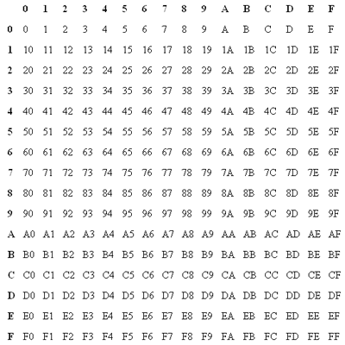

<http://www.had2know.com/computers/change-text-background-colors.html>

# How to Let Website Visitors Change the Background and Text Colors

You can add fun functionality to your website by letting your visitors change the text and background colors with simple dropdown menus. Try it:

|  |  |
| --- | --- |
| Top of Form  Background                                                                                           Bottom of Form | Top of Form  Text                                                                    Bottom of Form |

To add this option to your website, you need to create HTML id tags for the area in which the background color and text color will be changed. Then create two drop down menus with your choice of colors.  
  
**(Step 1)** Open your site in an HTML editor or Notepad so that you can edit the code by hand. First make sure that you have a DOCTYPE specified before the opening HTML tag. For instance, something like  
  
<!DOCTYPE HTML PUBLIC "-//W3C//DTD HTML 4.01 Transitional//EN" "http://www.w3.org/TR/html4/loose.dtd">  
  
**(Step 2)** Identify the area of your website where you want the colors to be changed and add this pair of div tags to the beginning of that section:

<div id='changemybg'><div id='changemytext'>

Now add this pair of closing tags at the end of the section:

</div></div>

If you save and compile, you'll notice that nothing has changed yet. This is because we haven't yet added the color-change script and dropdown menus. The id tags serve as name references for the next step.  
  
**(Step 3)** Locate the area where you want visitors to access the dropdown menus. Copy and paste these lines of HTML and JavaScript code:

<table width=300 border=0><tr>

<td align=center><form name=bcolors>Background<br><select NAME=bgc size=4

onChange="document.getElementById('changemybg').style.backgroundColor=bgc.options[selectedIndex].value">

<option VALUE="#FFFFFF">White </option>

<option VALUE="#F0F0FF">Light Blue </option>

<option VALUE="#FFFFD4">Light Yellow </option>

<option VALUE="#EEEEEE">Light Gray </option>

</select></form></td>

<td align="center"><form name=tcolors>Text<br><select NAME=tc size=4

onChange="document.getElementById('changemytext').style.color=tc.options[selectedIndex].value">

<option VALUE="#000000">Black </option>

<option VALUE="#444444">Charcoal </option>

<option VALUE="#000088">Dark Blue </option>

<option VALUE="#117722">Dark Green </option>

</select></form></td>

</tr></table>

Notice where the id tags are referenced by the "getElementById" commands. This code generates a set of dropdown menus with four background colors and four text colors. Each color is uniquely identified by a 6-digit hexadecimal number, as seen within the quotation marks.  
  
You can easily add more color choices by following the template and inserting additional option tags. To find more colors and their hex codes, see[December.com](http://www.december.com/html/spec/color.html), [Cloford.com](http://cloford.com/resources/colours/500col.htm), or the [Had2Know.com Color Generator](http://www.had2know.com/computers/css-color-picker-rgb-hsl-hex.html).